AllLinks

Author | Riaz
Date | 6-17-2015
Version | 1.0
Status | Draft

Document Revision History
Date | Version | SLDC Phase / Revision Description | Author
<< 2015-06-17 >> | 0.1 | Initial draft | Younus Mohammed
<< YYYY-MM-DD >>
<< YYYY-MM-DD >>
<< YYYY-MM-DD >>
<< YYYY-MM-DD >>

Table of Contents
Contents
Table of Contents
1 EXECUTIVE SUMMARY 4
2 vision/Scope Summary 5
3 Project requirement 6
3.1 Requirement Summary 6
3.2 System Requirement Summary 6
4 Business process overview 7
4.1 admin Flow 7
4.2 End User Flow 8
5 Modules and screens 9
5.1 User registration 9
5.2 User Login 9
5.3 Manage URL 9
5.4 URL Approved by admin 10
5.5 Browse URL 10
6 Unsupported features 11
6.1 Data Science 11
7 Assumptions, Dependencies and Constraints 12
7.1 Assumptions 12
7.2 Dependencies 12
7.3 Constraints 12
8 Appendices 13

EXECUTIVE SUMMARY
AllLinks is a web portal where a user can submit her/his portal URL under a specific category to be shared on link hub. Admin can approve or reject the URL submitted by the user and in each case an email is sent out to the user. Once the link is approved, it will be available on the link hub portal.

vision/Scope Summary

The proposed system should enable a platform for users to submit their urls under a category and business should be able to analyze the url data for decision making.
- User Registration
- Login
- Manage URL’s
- URL Review by and approve by Admins
- Browse all Approved URL’s

Project requirement
AllLinks performs various tasks. Users can submit their URL’s under a category and Admins can review the URLs and approve to be part of centralized DB for all URL storage area. It also enables business to performs their reports to understand the tendency of url categories.

Requirement Summary
The overall goal of the project is to enable users to submit their URL’s and enable business to perform data analysis.

- User Registration
- Login
- Manage URL’s
- URL Review by and approve by Admins
- Browse all Approved URL’s

As an end user of application following are high level requirement.

  - Two types of users are enabled for the system.
  - Admin
    - This is kind of system user defined by application owner.
    - When Admin logins he should have the feature to approve the submitted urls.
    - List should of Pending URL’s, Approved URL’s and Rejected URL’s.
  - End User
    - User should be able to login for valid user id and password after registration.
    - Login with facebook should be enabled.
    - There should be sign out button for logging out.
    - While submitting url user should provide Title of URL
    - URL link should be provided
    - URL Description should be provided
    - There should be a drop down for category of URL.

System Requirement Summary
- Application should support Internet Explorer, Chrome and Mozilla
- It should be compatible with all upgraded browsers.

Business process overview
AllLinks is a web based application.
There will be different set of users who will be using the application.

List of users are below
- Admin
- End User

admin Flow

- Central admin is capable of approving user Urls
- Central admin is capable of rejecting URLs

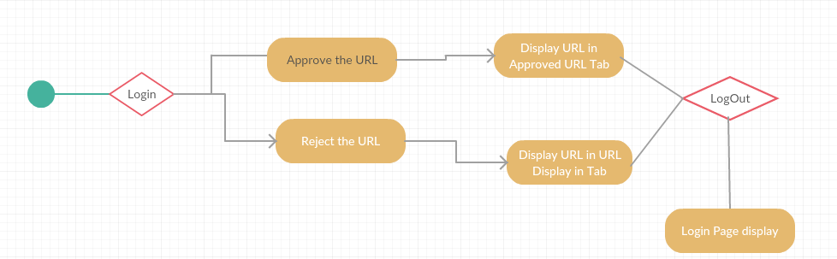

End User Flow
HR will be able to add/remove an employee and generate offer and reliving letter.
Also HR can generate Salary revision document.
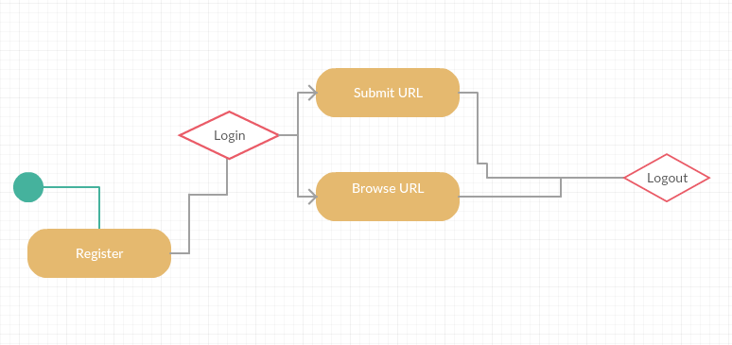

Modules and screens

User registration
User Registration form is below.

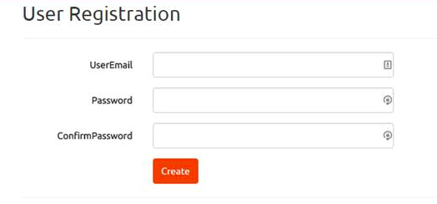

User Login
Login screen is below

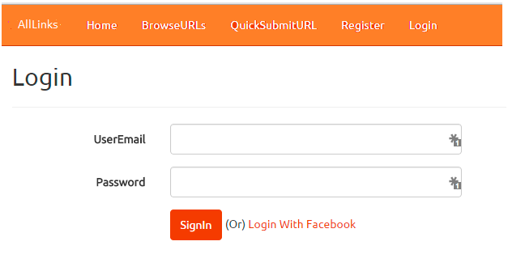

Manage URL
Login screen is below

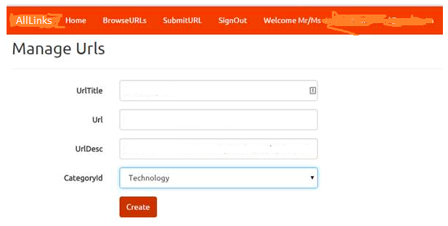

URL Approved by admin
This module depicts approvals of URL.
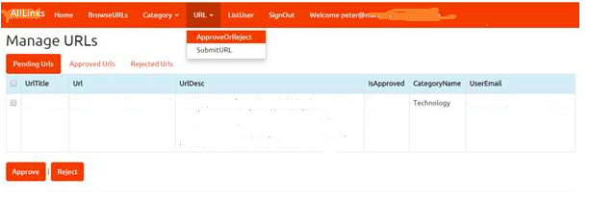

Browse URL
All approved URL’s can be viewed below.

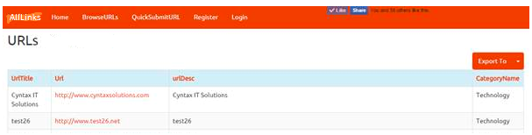

Unsupported features

Data Science
Basic reports will be generated. Data science module will be added as future enhancements.

Assumptions, Dependencies and Constraints

Assumptions
Factors assumed for the completion of this document that are considered to be true, real, or certain without proof or demonstration are identified in the following table.

# | Assumptions
1 | Application will be deployed on local machine not on web server
2 | There will be no formal go-live on internet unless investments comes in
Table 1: Assumptions

Dependencies
External factors or events that are linked to the solution (in that one has an effect on the other) are identified in the following table.

# | Dependencies
1 | Employee monitoring will be done through external tool.

Constraints
Factors that limit or slow the successful development, deployment or adoption of the solution are identified in the following table.
# | Constraints
1 | Employee monitoring will be relied on third party tool as timelines for project very short.

Appendices

